ST GEORGES SURGERY
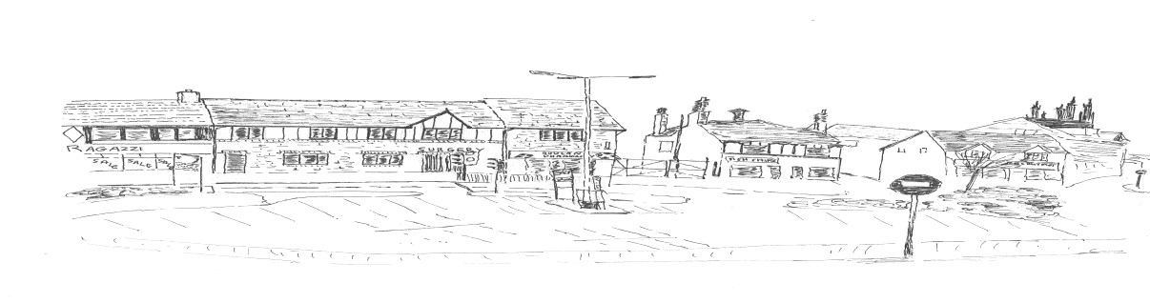

40
St George’s Crescent

Wrexham LL13 8DB

Telephone No. 01978 290708 www.stgeorgescrescentsurgery.co.uk Fax 01978 290836

Partners:
Dr Samir Naseef (Senior Partner)

Dr Aamir Ehsan

Nurses:
Advanced Nurse Practitioner Elizabeth Neale RCN

Sister Nia Hughes RCN

Sister Delyth Parry RCN

Practice Manager
Mrs Mair Harris

Assistant Practice Manager Operations
Linda Cousins

Assistant Practice Manager Business
Donna Holland

Introduction

The Practice offers a variety of in-house services with improved disabled access and a lift to the first-floor areas. For those with hearing difficulties we have a portable hearing loop system available.

We have 2 full-time Partner GP’s (not a Limited
Partnership), Locum GP’s, 1 Advanced Nurse Practitioner, 2 Practice nurses and an Independent Prescriber.

We are situated in the town centre. The Practice is on a bus route and within walking distance for many of our patients.

A map showing the Practice boundary is on page 4.

Our Service To You

We are a friendly team of professionals whose aim is to look after you and the health needs of your family. All staff are trained to put your needs first, so if you are worried or unsure then do, please ask and we will be pleased to help.

We currently offer what we hope is a user-friendly service that people find easy to access. The principles we adopt reflect themselves in the caring, courtesy and quality of the service that we offer.

As part of our plans to improve our service to you we have produced this booklet and a website which tells you about the Practice and how to access the service we provide. We try to keep them up to date but there will always be some changes, which will find their way into later editions. The booklet is available in large print. A Welsh translated version is available on request.

Zero Tolerance Policy

The Practice operates a zero-tolerance policy whereby any patients who are violent or verbally abusive to any member of the Practice Team or other persons present on the practice premises, the patient will receive a warning letter regarding unacceptable behaviour. The letter will also inform the patient that if any further incidents of this nature should happen again in the next twelve months they will be removed from St Georges Surgery patient list.

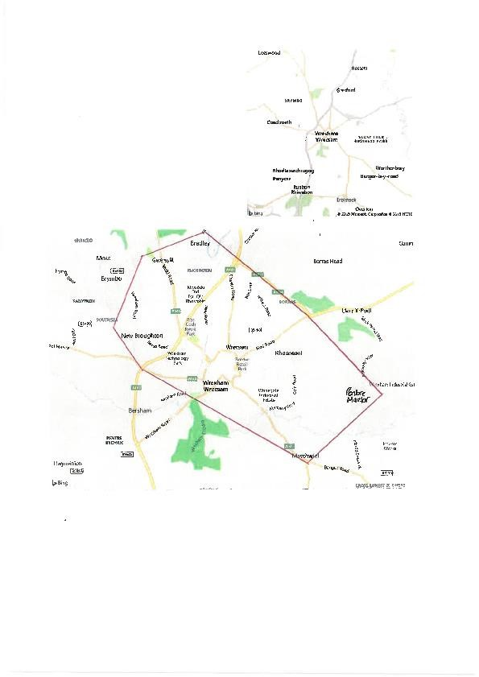

Surgery Opening Hours

MONDAY | 8.30 am – 6.00 pm
TUESDAY | 8.30 am – 6.00 pm
WEDNESDAY | 8.30 am – 4.00 pm
THURSDAY | 8.30 am – 6.00 pm
FRIDAY | 8.30 am – 6.00 pm
SATURDAY | Closed
SUNDAY | Closed

Monday | GP’s | 8.40 a.m.-11.30 a.m. | 3.15 p.m.-6.00 p.m.
 | Nurses | 9.00 a.m.-11.30 a.m. | 2.15 p.m.-3.45 p.m.
Tuesday | GP’s | 8.40 a.m.-11.30 a.m. | 3.15 p.m.-6.00 p.m.
 | Nurses | 8.45 a.m.-11.45 a.m. | 2.00 p.m.-5.15 p.m.
 | PCMH | By appointment only
Wednesday | GP’s | 8.40 a.m.-11.30 a.m. | 2.00 p.m.-4.00 p.m.
 | Nurses | 9.30 a.m.-11.30 a.m. | 2.00 p.m.-2.30 p.m.
Thursday | GP’s | 8.40 a.m.-11.30 a.m. | 2.00 p.m.-6.00 p.m.
 | Nurses | 8.45 a.m.-11.30 a.m. | 2.00 p.m.-4.45 p.m.
 | Midwife | By appointment only
Friday | GP’s | 8.40 a.m.-11.30 a.m. | 2.00 p.m.-6.00 p.m.
 | Nurses | 8.45 a.m.-11.45 a.m. | 2.15 p.m.-5.00 p.m.

All Surgery times are by appointment, but urgent cases can be seen on the same day at the end of surgeries. We will always see emergencies on the day you request for children under 16 but you may have to wait to see a particular doctor for a routine appointment. For some symptoms, you may be directed towards an alternative healthcare professional such as a Pharmacist, Physiotherapist, Dentist, or Optician.

Appointments

We run fully computerised appointment system. Please telephone 01978 290708 if you need to book one or see below for more information.

The My Health Online system also allows appointments to be booked and cancelled through the website.
Please ask reception staff for more information.

Routine Appointments

Generally booked at 10-minute intervals and are available up to 4 weeks in advance for a doctor of your choice. If the Doctor of your choice is not available, we are happy to arrange for you to see another Doctor sooner by asking our reception staff. For a non-urgent appointment or call back send an email to enquiries.w91030@wales.nhs.uk. but this is not intended for simple administrative tasks or requesting prescriptions.

Emergency Appointments

If all appointments are taken and you feel your problem is an emergency, then you will be given an emergency appointment with the duty Doctor. They will decide how they can best help you. These are only 10-minute appointments and are not for dealing with long standing problems. Patients requesting same day appointments whose condition is not thought to be medically urgent may be offered a consultation with one of our Practice Nurses. A brief explanation of your problem may enable the receptionist to offer the most suitable appointment.

If you are unable to keep an appointment, please advise reception as soon as possible so that the appointment can be offered to another patient. This can also be done by following the instructions on your SMS appointment reminder text. Please let us know if you do not receive this reminder 2 days before your appointment as there may be a problem with the number we have recorded on your record.

Telephone Advice

To book a telephone advice call with the doctor, we suggest you ring anytime from 8.30am to book the call, and the consultation will take place from 12.00 noon to 12.30pm either on the day or over the next few days.

Home Visits

Visits are for those too ill to go out or who are housebound. Please phone before 10.30 a.m. if possible.

Out of Hours

When the surgery is closed there is always a doctor on- call for emergencies, either one of our doctors or a doctor from North Wales GP Out-of-Hours. When the Surgery is closed, please ring the Betsi Cadwaladr
University Health Board commissioned OOH Service on 111 or for advice ring NHS Direct on 0845 46 47 or visit https://www.nhsdirect.wales.nhs.uk/

Repeat Prescriptions

You can call into the Surgery and drop off your request slip, post it to the Surgery or make arrangements with your local chemist. Telephone requests are no longer taken. Please allow 48 hours before collection of your prescription or 72 hours if going to the Chemist for collection or home delivery. Repeat prescriptions when they are due, can also be ordered electronically through our My Health Online system – please ask reception for further details or check out our website.
www.stgeorgescrescentsurgery.co.uk

Test Results

Please ring for test results after 2p.m. as we receive results after this time. The normal time scale for availability of results is as follows:
Blood tests: 5 working days.
X-rays/ultrasound/ CT/MRI: 14 working days Minor surgery specimens: 14 working days. Urine samples: 3 days

Specimens

You should only bring blood, urine samples etc to the reception in the correct container with your name and date of birth on. Containers are available from Reception. The last collection from the Surgery is
3.00 p.m. Alternatively, you can deliver the sample directly to the Path Lab yourself.

General Administration

In order to keep your medical records up-to-date, we need to know if you change your name, address, telephone number or any other personal details that change.

Failure to notify any changes may result in your removal from our list due to undelivered mail being returned.

Complaints and Suggestions

The Practice operates a complaints procedure, if you have any complaints, comments, or suggestions about any aspect of the Practice please contact our Practice Manager. Further details can also be found in our complaint leaflet which is available from Reception.

Patients Rights and Responsibilities

Your medical records are held in the strictest confidence. Information is not passed on without your consent unless it is within the confines of the NHS, by legal framework, or is in the public interest. Certain anonymous patient data may be shared for the purpose of public health and audit, research, teaching and training. You have a right to see your health records, which will be kept confidential, subject to any limitations in the law. If you would like to see your records, please apply in writing to the Assistant Practice Manager.

You will be treated as an individual and will be always given courtesy and respect, irrespective of your race, gender, disability, social class, religious beliefs, sexual orientation or appearance or the nature of your health problems. We ask that you also treat the doctors and Practice staff with courtesy and respect and show consideration to other patients by making responsible use of our service to you.

No care or treatment will be given without your informed consent.
In the interest of your health it is important for you to understand all the information given to you. Please ask us questions if you are unsure of anything.

Please remember that you are responsible for your own health and the health of your children.

You can help us by being on time for your appointment and letting us know in advance if you are unable to keep an appointment.

Freedom of Information

Our Freedom of Information policy is available from the Practice Manager.

Car Parking

You can park outside the Surgery for up to 1 hour free of charge or the car park across the road from the Surgery, at a reasonable cost.

The Primary Health Care Team
In addition to the doctors, the following are available for advice and consultation in the Surgery.

Practice Nurses

The Practice nurses carry out new patient examination checks, blood pressure checks, travel vaccinations, cervical smears, blood tests, repeat contraceptive pill and HRT checks. Also, health checks available for patients over the age of 75 years or who haven’t attended in the last 3 years.

Please ask at Reception for an appointment to see the nurse.

Health Visitor (Based at Grove Road)

Baby Clinic is held every Wednesday at Grove Road between 9.00 a.m. and 4.00 p.m. drop-in. No appointment is necessary. They are available for advice on health matters for the under-fives.

Community Midwives

The midwives visit the Surgery once a week for booking of pregnant women and to provide antenatal care.

How the Practice Operates to Register

Please ask at Reception to request an application form or you can complete the patient registration form online by clicking on the link. Please ensure that you give as much information on your registration form and also on the patient questionnaire, as this information is then added to your computer record.
Special Services
Please ask at Reception regarding the following services provided by the Surgery:
Antenatal care, postnatal examinations and Baby Immunisations.
Family planning including contraceptive injections.
Foreign travel advice and vaccinations. Diabetic, CHD, Asthma, COPD and Hypertension
Clinics.
Well woman health checks and cervical smear tests. Smoking cessation

Change of Personal Details

If you change your name, address or contact number especially mobile phones, please notify the Surgery as soon as possible including details of dependants.

Making It Work

We hope you have found this leaflet useful. If you have any suggestions, or ideas of improvements we can make, please contact our Practice Manager.

INTERNET LINKS

For information relating to all health services in the
Wrexham area including GP Surgeries and Dentists.

BETSI CADWALADR UNIVERSITY HEALTH BOARD

‘Preswylfa’ Hendy Road Mold
CH7 1PZ

Telephone: 03000858685 advice on local health services.

Website:
www.bcu.wales.nhs.uk

NHS DIRECT WALES

Telephone: 0845 46 47 www.nhsdirect.wales.nhs.uk
24-hour confidential helpline providing advice and information on

- What to do if feeling ill
- Health concerns for you and your family
- Local Health Services
- Self help and support organisations

ORGAN DONOR

NHS UK Transplant saves lives through organ donation and transplantation. It provides a 24-hour service for the matching and allocation of donated organs throughout the UK. It also maintains the Organ Donor Register.

For information about organ donation and transplantation
Organ Donor Line 0845 60 60 400 www.uktransplant.org.uk

BLOOD SERVICE

For information regarding The National Blood Service, including where to give blood

Telephone: 0845 7 711 711 www.blood.co.uk

ASTHMA

Asthma UK Adviceline - Telephone:08457 01 02 03
Supporter and information Team: 020 7786 5000

Telephone: 020 7256 6075 Fax 020 7256 6075
Asthma UK
Summit House
70 Wilson Street London EC2A 2DB
www.asthma.org.uk

EPILEPSY

For information about any aspect of epilepsy, to request literature or to share your experiences contact.
Epilepsy Action
New Anstey House
Gate Way Drive
Yeadon
Leeds
LS19 7XY

Freephone Epilepsy Helpline: 0808 800 5050
Free fax:0808 800 5555 www.epilepsy.org.uk

CARERS

Wrexham Carers Service
21 Egerton Street
Wrexham LL11 1ND

Telephone: 01978 312556 Fax: 01978 263980
Email: carers@avow.org
Wrexham Carers Service provides support, advice and information to Carers looking after family or relatives. http://hermitage47.webspring.org.uk/health-socialcare/carers

AVOW

Association of Voluntary Organisations in Wrexham

21 Egerton Street Wrexham
LL11 1ND

Telephone: 01978 312556
www.avow.org

AVOW is the County Voluntary Council for Wrexham County Borough committed to the development of a strong voluntary sector for the benefit of the people of Wrexham County Borough.

PATIENT UK

Health and information at your fingertips.
A directory of UK health, disease, illness, and related medical websites that provide patient information.
www.patient.co.uk

